Case 6-Afr-Burkina Faso-Mossi-Yatenga Mask with Figure-Wood-1st part 20th c

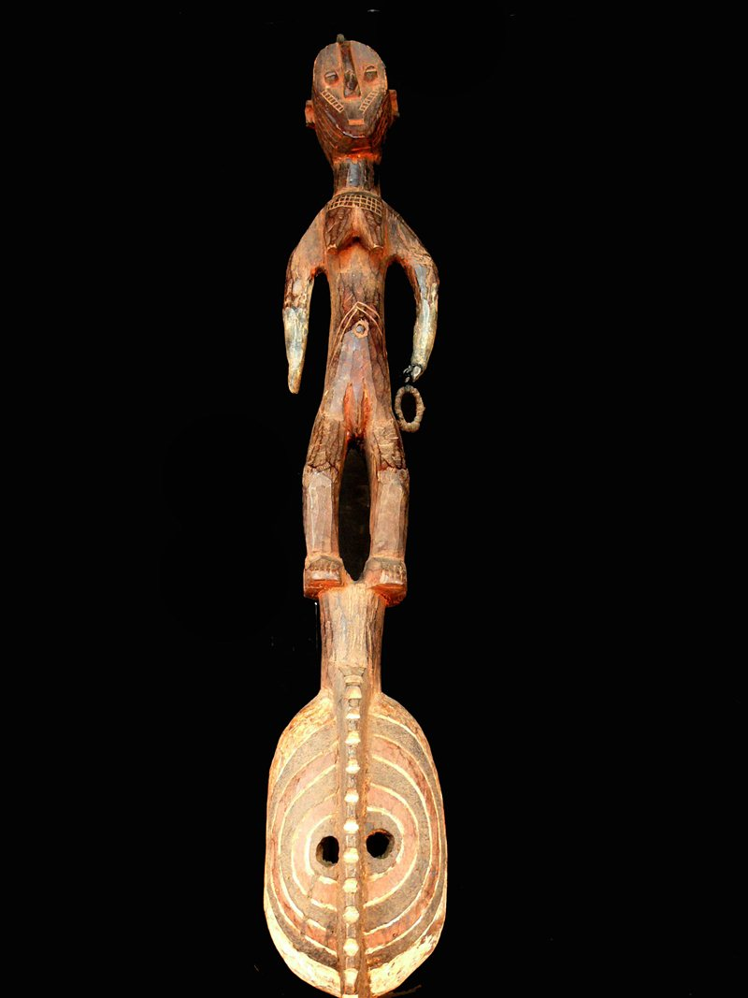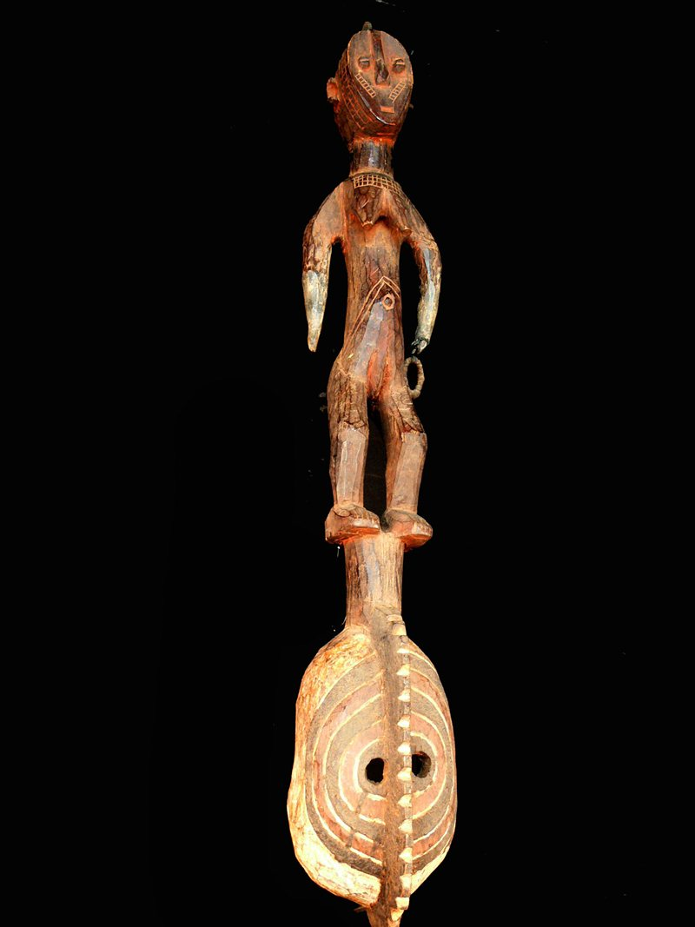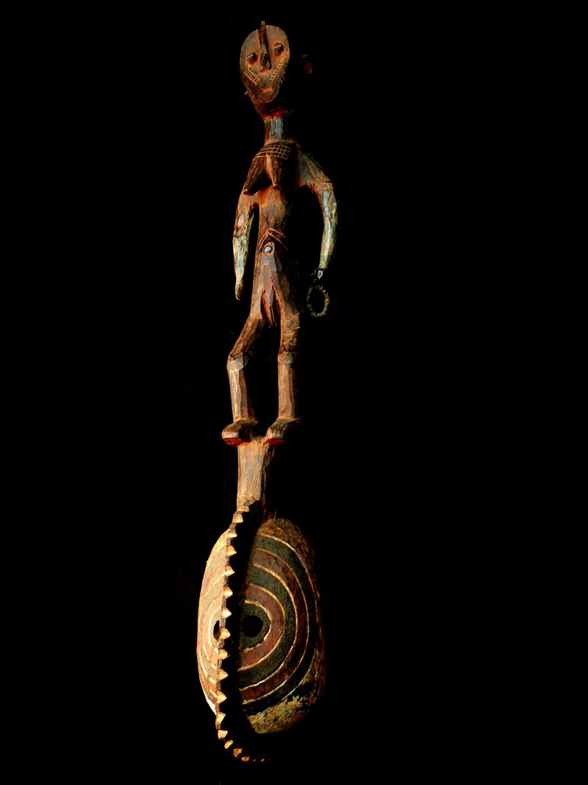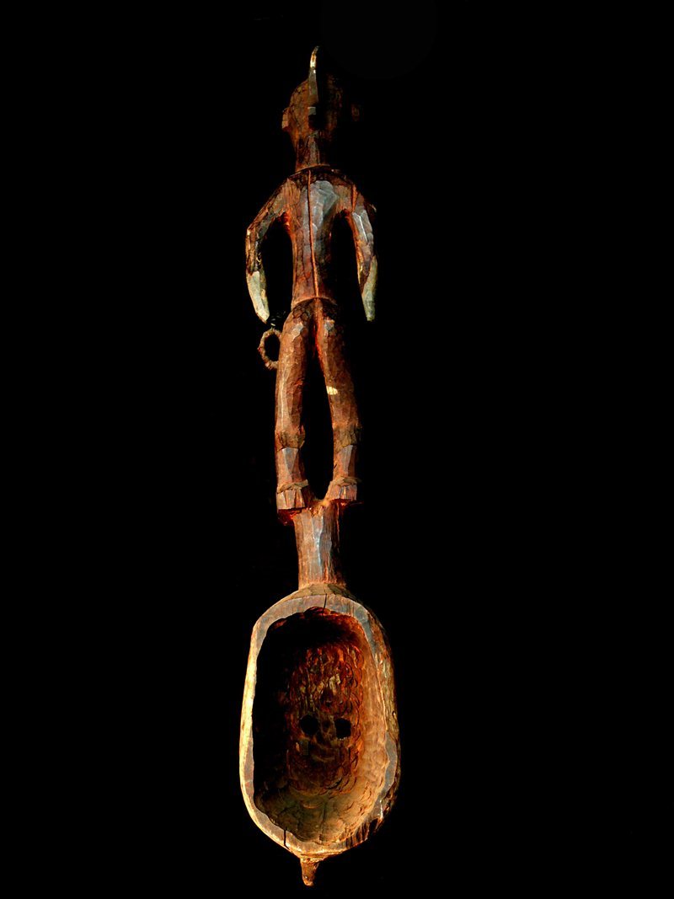

Case No.: 6

Accession Number:

Formal Label: Afr-Burkina Faso-Mossi-Yatenga Mask with Figure-Wood-1st part 20th c

**Display Description:**

Mossi living in Burkina Faso have developed Yatenga masks that combine stylized humans with geometric shapes as in this mask that has an ancestral mother figure who is surmounted on an oval-shaped face painted with concentric, alternating black and red circles on which is bisected by a vertical serrated crest that evokes a powerful creator spirit. This type of mask is produced exclusively in the northeastern area of Mossi country, in the Yatenga region.  
In Mossi society, the male head of a clan possesses a mask that evokes an important maternal totem that is profoundly and inextricably associated with his family's origin myth. The clan and its are. They share the same life force, and each clan member's soul is inseparable from the maternal totem. Totemic masks like this one are intended to serve as direct lines of communication between their owners and the founding members of their extended family. Each year the clan applies libations to its masks at a community ritual which occurs in May just before the beginning of the rainy season. Appeals are made for an early and abundant rainy season as well as for the general well-being of the entire clan during the coming year.   
  
Mossi masks, so central to a family's founding as well as to its more recent past, present, and future, also play a prominent role in assuring a smooth transition to the afterlife. During the burial of any male or female clan elder, masks escort the body to the grave and ensure that all burial procedures are properly followed. At the conclusion of the rites, the spirits' union with clan ancestors is joyfully celebrated with dances in which performers imitate the motions of the maternal totem their masks depict.

LC Classification:

Date or Time Horizon:

Geographical Area:

Map:

GPS Coordinates:

Cultural Affiliation:

Medium: wood

**Dimensions**: H 44 in  
**Weight:** 2.91 **lbs**

**Provenance**:

**Condition:**

**Discussion:**

**References:**

Solomon, H. and Anderson-Spivy, A., 1988. Discovering a Culture. In  *Living with Art*. Rizzoli International Publications, pp. 116–20.

Roy, C.D. and Lehuard, R., 1984. Forme et signification des masques mossi. *Arts d'Afrique Noire Arnouville*, (48), pp.9-23.

Wheelock, T.G. and Roy, C.D., 2007. *Land of the Flying Masks: Art and Culture in Burkina Faso; the Thomas GB Wheelock Collection*. Prestel Pub.